<http://vhlong.blogspot.com/2014/03/database-huong-dan-chuyen-database-sql.html> (cách chuyên CSDL từ máy này đến máy khác )

<https://www.youtube.com/watch?v=eq-8M2q6XVI> (Cách tạo cơ sở dữ liệu quản lý bán hàng cơ bản)

<https://www.youtube.com/watch?v=vQAktMh958I> (Hướng dẫn làm quản lý bán hàng, bài làm tham khảo)

<http://kedehang24h.blogspot.com/2014/09/danh-muc-hang-hoa-sieu-thi-tap-hoa-tieu.html> (Danh sách và giá các mặt hàng tiêu dùng cơ bản của siêu thị)

<https://drive.google.com/open?id=0B7gT2HRM9mVySWZmWXRuYnhhLXc>

<https://docs.google.com/forms/d/e/1FAIpQLScE-8JGlElQcgdC-AzXBO_8NvMVGYVL3VQsRhkgtznJQ96eow/formResponse>

<http://o7planning.org/vi/10283/huong-dan-su-dung-github-voi-github-desktop#a70588> (tạo tài khoản và cài đặt github)

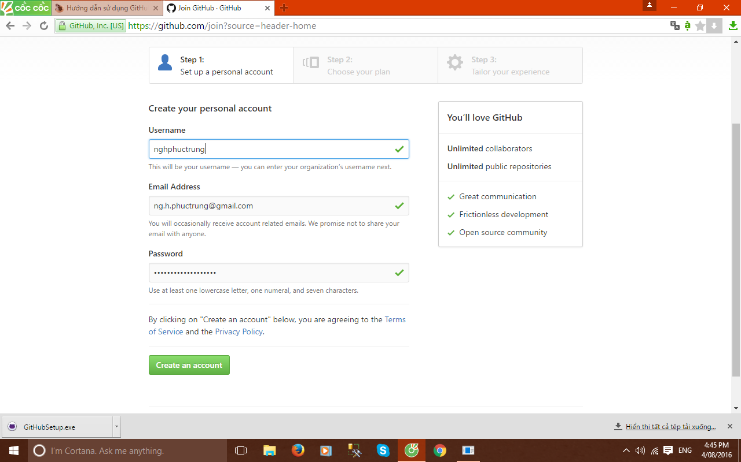

<https://www.youtube.com/watch?v=fmWPISPgW_E> (telerik demo)

<https://www.youtube.com/watch?v=LqujUDmG76g> (thêm xóa sửa , quan trọng)

<https://www.youtube.com/watch?v=cRl9uCXl7Xs> (telerik gridview)

<https://www.youtube.com/watch?v=o9Rn4qTYjnY> (testing telerik radgridview)

<https://www.youtube.com/watch?v=t3cR7A5VjdY> (demo design)

<http://docs.telerik.com/devtools/winforms/gridview/rows/iterating-rows> (telerik tool)

<https://www.youtube.com/watch?v=RHgMwE2vlsc> (radScheduler for winform)

<https://www.youtube.com/watch?v=fmWPISPgW_E> (theme button)

<https://www.youtube.com/watch?v=h2LBjWoMy_g> (using telerik)

<https://www.youtube.com/watch?v=asUVjL0q13E> (load dữ liệu)

<https://blacksheep1135.wordpress.com/2011/07/01/ajax-paging-with-radcontrol/> (chỉnh sửa radgridview)

<http://www.mediafire.com/download/in34xs77nchov3q/Do+an+mon+hoc_Chuong+trinh+quan+ly+sinh+vien+bang+Microsoft+Visual+Studio+C%23+2008.ppt> (đồ án thiết kế quản lý)

<https://www.youtube.com/watch?v=3a-Gp8faFCM> (đồ án trên youtube)

<http://www.telerik.com/videos/winforms/binding-radgridview-for-winforms-to-openaccess> ()

<http://docs.telerik.com/devtools/winforms/gridview/populating-with-data/updating-the-database-with-ado.net> (update)

<http://docs.telerik.com/devtools/winforms/gridview/populating-with-data/updating-the-database-with-ado.net> (them xoa sua ) **Quan Trọng**

<https://www.youtube.com/watch?v=bd5sNStmboE>

<https://www.youtube.com/watch?v=t3cR7A5VjdY> form 2

<https://www.youtube.com/watch?v=zOefoGRGKGI> (form đăng nhập)

<https://github.com/nghphuctrung/Demo.git> (nháp)

<https://github.com/nghphuctrung/BaoCaoDeTaiTelerik.git> (link github)

////USING QLBanHang

//GO

// --- viet thu tuc (Stored procedure) them mot loai sp

// IF OBJECT_ID ('uspThemLoaiSP','P') IS NOT NULL

// DROP PROC uspThemLoaiSP

// GO

//CREATE PROC uspThemLoaiSP

// @maLoaiSP int ,

// @tenLoaiSP nvarchar (255)

//AS

// -- IF EXIST () KIEM TRA TRUOC KHI THEM

// INSERT INTO LoaiSP(MaLoaiSP, TenLoaiSP)

// VALUES (@maLoaiSP, @tenLoaiSP)

//GO

//EXEC uspThemLoaiSP 15 , N'aaaa'

using System;

using System.Collections.Generic;

using System.ComponentModel;

using System.Data;

using System.Drawing;

using System.Linq;

using System.Text;

using System.Windows.Forms;

using System.Data.SqlClient;

using Telerik.WinControls.UI;

using Bailamcodetelerik.QLSTDatasetTableAdapters;

namespace Bailamcodetelerik

{

public partial class RadForm1 : Telerik.WinControls.UI.RadForm

{

static string Str = @"Server = .; Database = QLyBanHangSieuThi ; Integrated security = true ";

SqlConnection cn = new SqlConnection(Str);

public RadForm1()

{

InitializeComponent();

}

private void RadForm1_Load(object sender, EventArgs e)

{

**// Đổi tên các cột trong gird view thành tiếng việt**

radGridView1.MasterTemplate.Columns.Add("MaLoai", "Mã Loại", "MaLoaiHH");

radGridView1.MasterTemplate.Columns.Add("TenLoai", "Tên Loại", "TenLoaiHH");

radGridView1.MasterTemplate.DataSource = loadMaLoai();

GridViewTemplate firstChildtemplate = new GridViewTemplate();

**// Gird view con**

firstChildtemplate.Columns.Add("Mahanghoa", "Mã Hàng Hóa", "MaHH");

firstChildtemplate.Columns.Add("tenhanghoa", "Tên Hàng Hóa", "TenHH");

firstChildtemplate.Columns.Add("giabanhh", "Giá Bán", "GiaBan");

firstChildtemplate.Columns.Add("dvt", "Đơn Vị Tính", "DonViTinh");

firstChildtemplate.Columns.Add("MaLoai", "Mã Loại", "MaLoaiHH");

firstChildtemplate.Columns["MaLoai"].IsVisible = true;**//ẩn đi bảng mã loại**

firstChildtemplate.DataSource = loadHangHoa();

radGridView1.MasterTemplate.Templates.Add(firstChildtemplate);

firstChildtemplate.EnableFiltering = true; **// Lọc dữ liệu**

firstChildtemplate.AutoSizeColumnsMode = GridViewAutoSizeColumnsMode.Fill;

GridViewRelation relation = new GridViewRelation(radGridView1.MasterTemplate);

relation.ChildTemplate = firstChildtemplate;

relation.RelationName = "111";

relation.ParentColumnNames.Add("MaLoai");

relation.ChildColumnNames.Add("MaLoai");

radGridView1.Relations.Add(relation);

GridViewTemplate secondChildtemplate = new GridViewTemplate();

**// Gridview cháu**

secondChildtemplate.Columns.Add("MaHoaDon", "Mã Hóa Đơn", "MaHD");

secondChildtemplate.Columns.Add("MaHangHoa", "Mã Hàng Hóa", "MaHH");

secondChildtemplate.Columns.Add("Dongia", "Đơn Giá", "DonGia");

secondChildtemplate.Columns.Add("SL", "Số Lượng", "SoLuong");

secondChildtemplate.Columns.Add("TT", "Thành Tiền", "ThanhTien");

secondChildtemplate.DataSource = Chitiet();

firstChildtemplate.Templates.Add(secondChildtemplate);

secondChildtemplate.EnableFiltering = true;

secondChildtemplate.AutoSizeColumnsMode = GridViewAutoSizeColumnsMode.Fill;

GridViewRelation relation2 = new GridViewRelation(firstChildtemplate);

**// quan hệ giữa các gird view**

relation2.ChildTemplate = secondChildtemplate;

relation2.RelationName = "222";

relation2.ParentColumnNames.Add("Mahanghoa");

relation2.ChildColumnNames.Add("MaHangHoa");

radGridView1.Relations.Add(relation2);

}

private DataTable GetData(string sql)

{

try

{

cn.Open();

SqlCommand cmd = new SqlCommand(sql, cn);

SqlDataAdapter da = new SqlDataAdapter(cmd);

DataTable dt = new DataTable();

da.Fill(dt);

cmd.Dispose();

return dt;

}

catch (Exception)

{

throw;

}

finally

{

cn.Close();

}

}

public DataTable loadMaLoai()

{

string sql = "SELECT * FROM Loai_HH";

DataTable dt = GetData(sql);

return dt;

}

public DataTable loadHangHoa()

{

string sql = "SELECT * FROM HangHoa";

DataTable dt = GetData(sql);

return dt;

}

public DataTable Chitiet()

{

string sql = "SELECT * From ChiTietHoaDon";

DataTable dt = GetData(sql);

return dt;

}

}

}